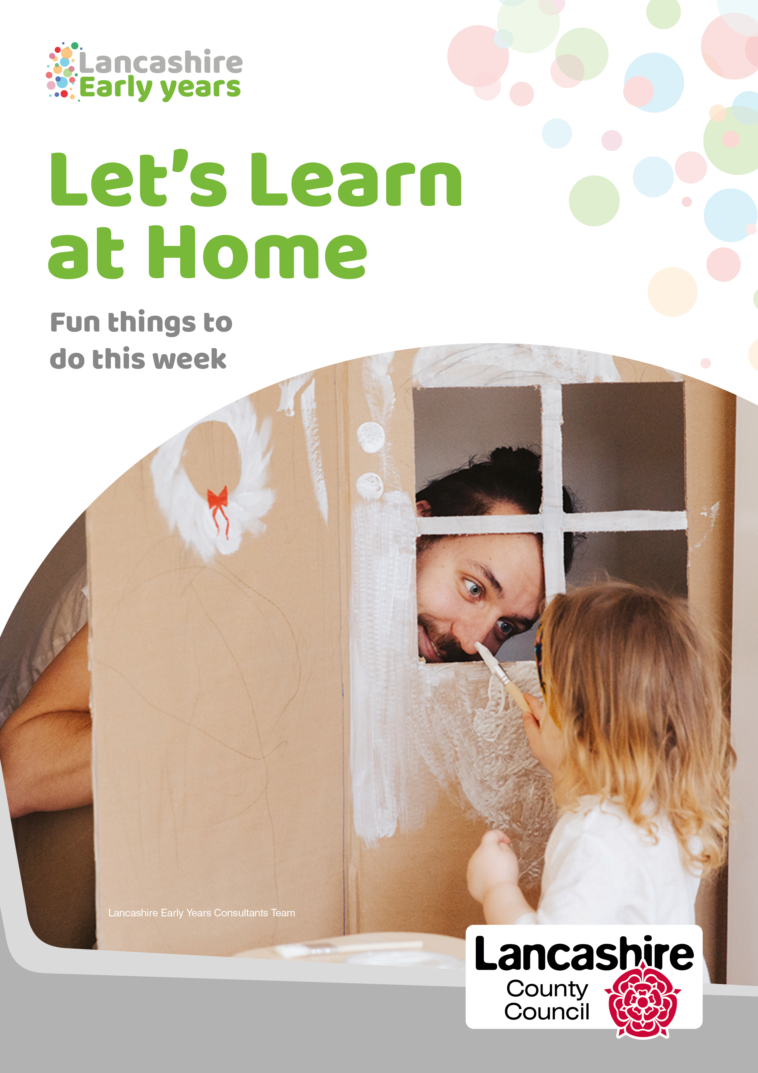

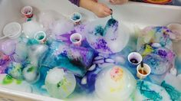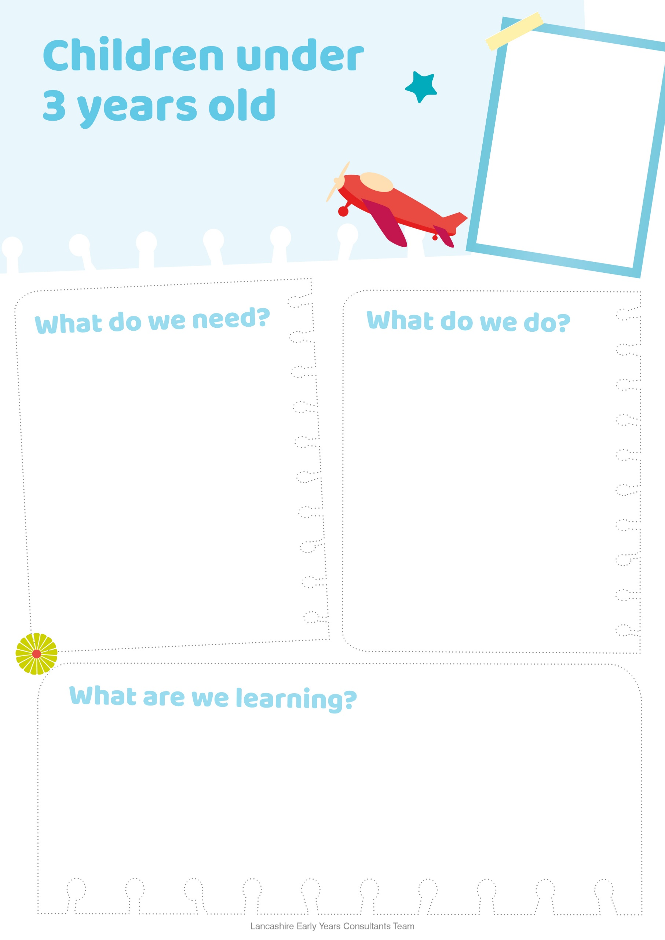

* Freeze a variety of colours in the ice cube tray and yogurt pots
* When frozen take out of freezer and place on a tray
* Help your child tip out the containers with the ice in
* Fill container with cold water and let your child pick which colour of ice they want to put in the water
* Watch how the colours begin to mix
* Describe to your child what is happening
* Use language for e.g. warm, cold and freezing
* Repeat using warm water and talk about the colours and how the ice is melting

**Little Scientist**

Experiments to try at home

* Ice cube trays
* Small yogurt pots
* Water - cold and warm
* A selection of food colourings
* Large clear plastic container
* Tray
* Fine motor skills
* Communication and language (new vocabulary)
* developing their senses
* Cause and effect
* Exploring colours
* Experiments and exploring with different materials
* Begins to understand temperature (warm and cold)
* concentration

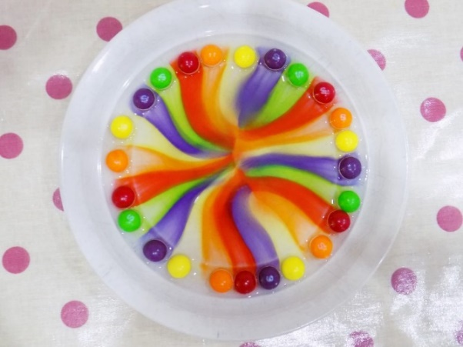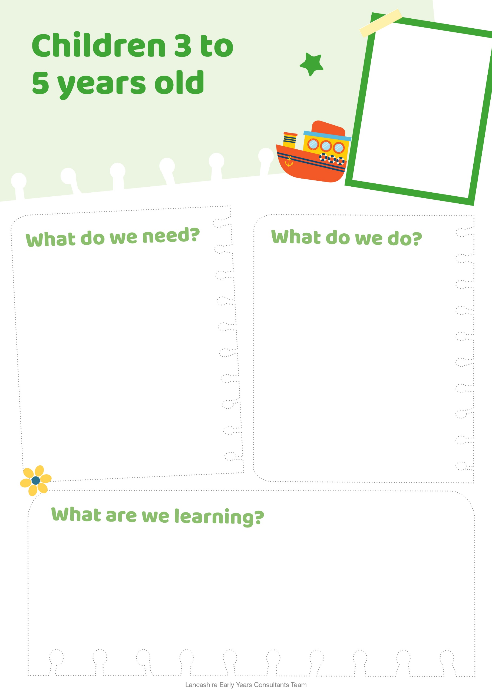

* 2 bags of Skittles
* Small white plate
* Warm water
* Coloured bowls for sorting (optional)

* **Creativity**
* **Cause and effect**
* **How to create different colours**
* **Fine motor skills**
* **Use resources independently**
* **Maths (patterns)**
* **Exploring a variety of materials**
* **Fascination (Awe and wonder)**
* First tip all the skittles out into a big bowl and start sorting out the colours
* You could make this slightly trickier by using tweezers
* Once all the skittles are sorted into colours, lay them out in different patterns around the plate
* Tip a cup of warm water over the skittles so they are just covered
* Watch the magic happen
* Try different colour combinations and patterns for different effects
* Talk to your child and discuss what is happening

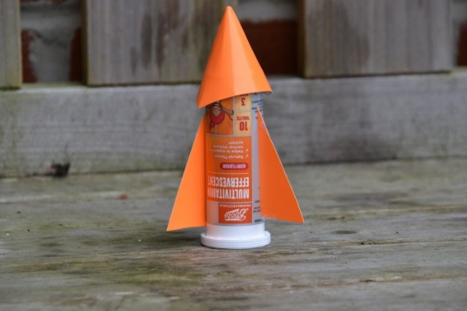

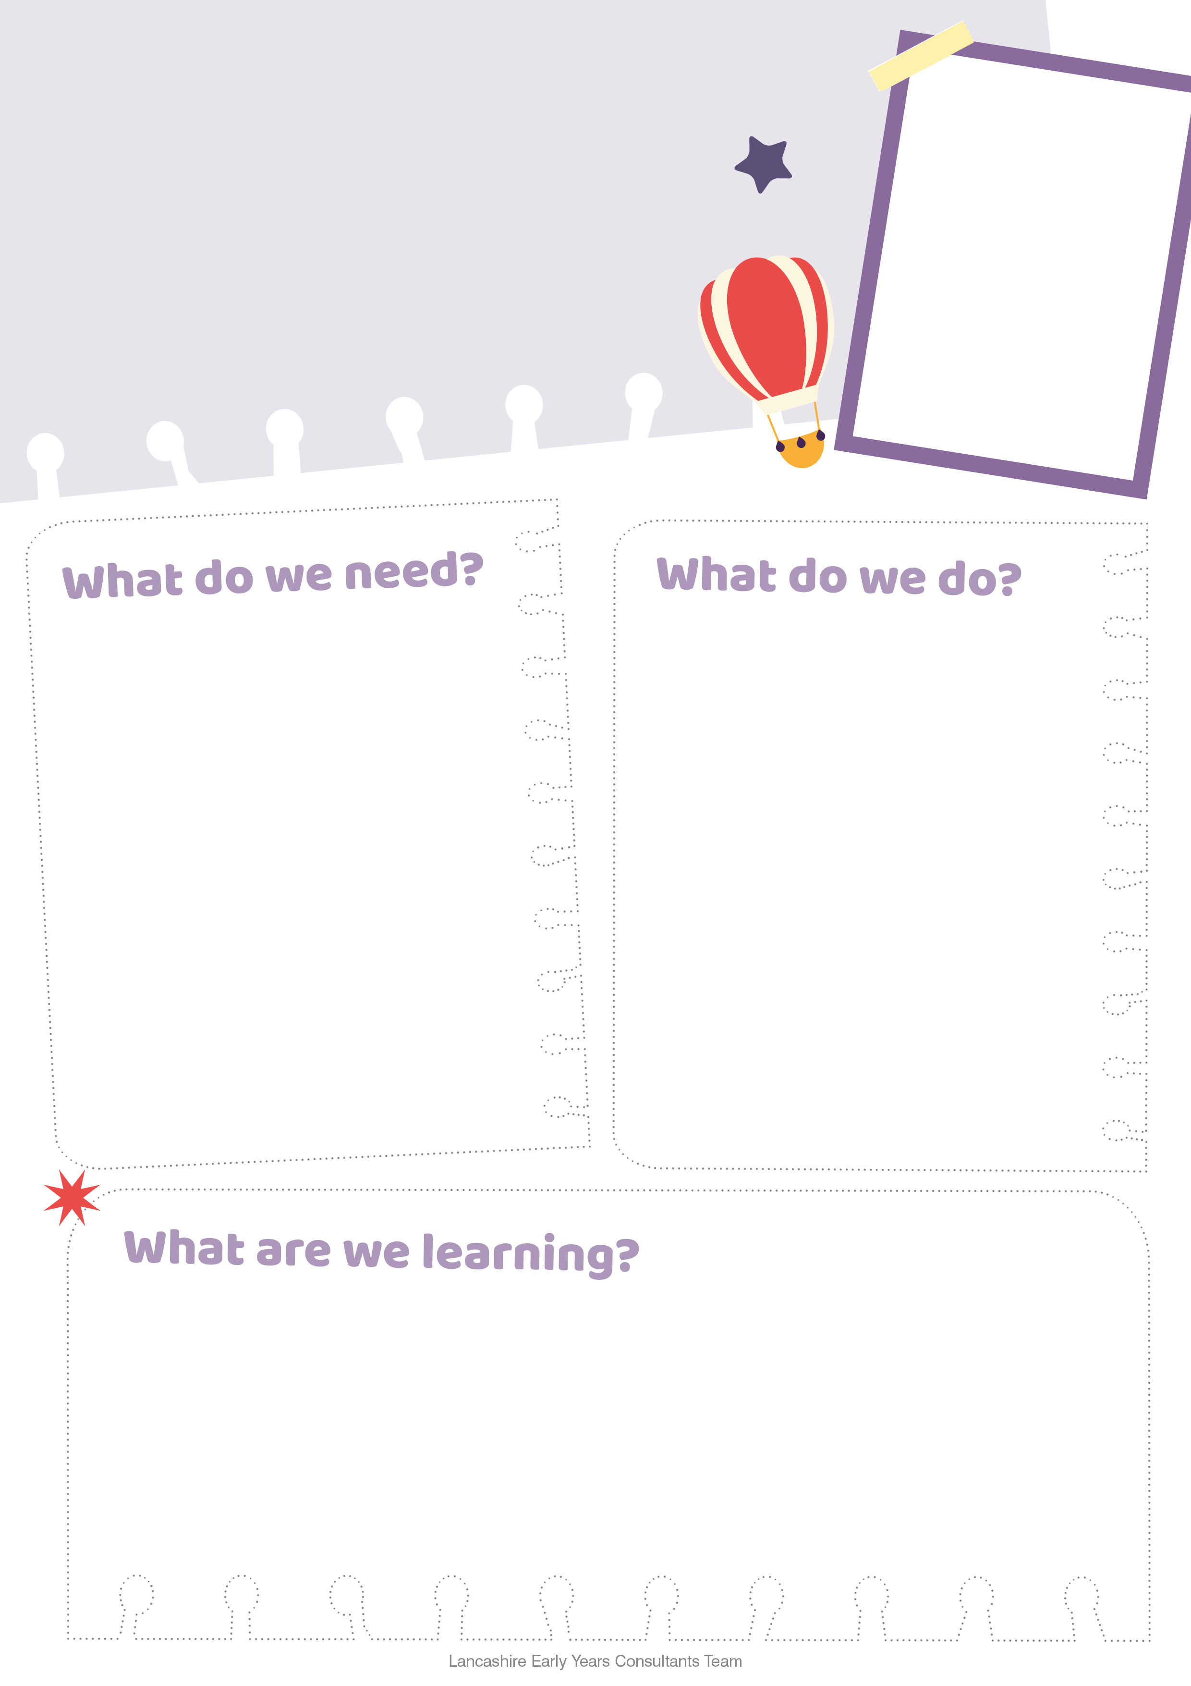

* Creativity
* How to create an experiment
* Follow instructions
* Descriptive language
* Fascination
* Early science
* Moving and handling
* Recognising things in the living world around them.
* Curiosity and an interest in the outdoors
* Add about one centimetre of vinegar to the bottom of the canister
* Drop in a little baking soda
* Put on the lid and step back
* Watch what happens, the top flies off almost immediately

To try and slow the reaction down wrap the baking soda in a small piece of kitchen towel, which may give you enough time to put the canister down and grab a camera

* A container with a lid
* Vinegar
* Baking Soda
* Kitchen Roll

**This experiment should ideally be done outside as it can be quite messy but fun**

